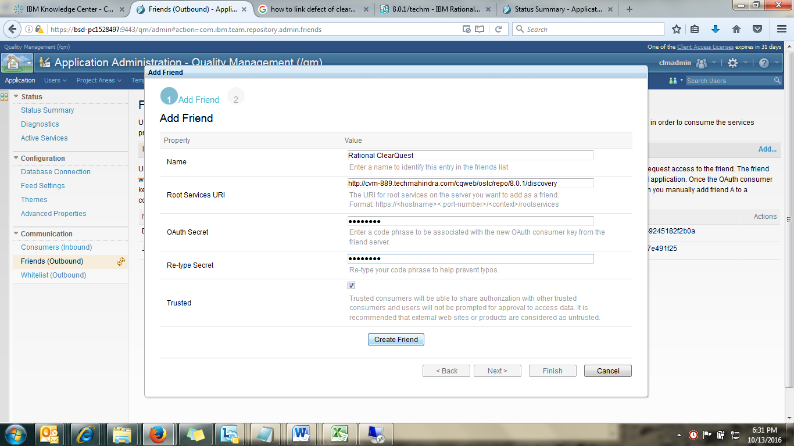

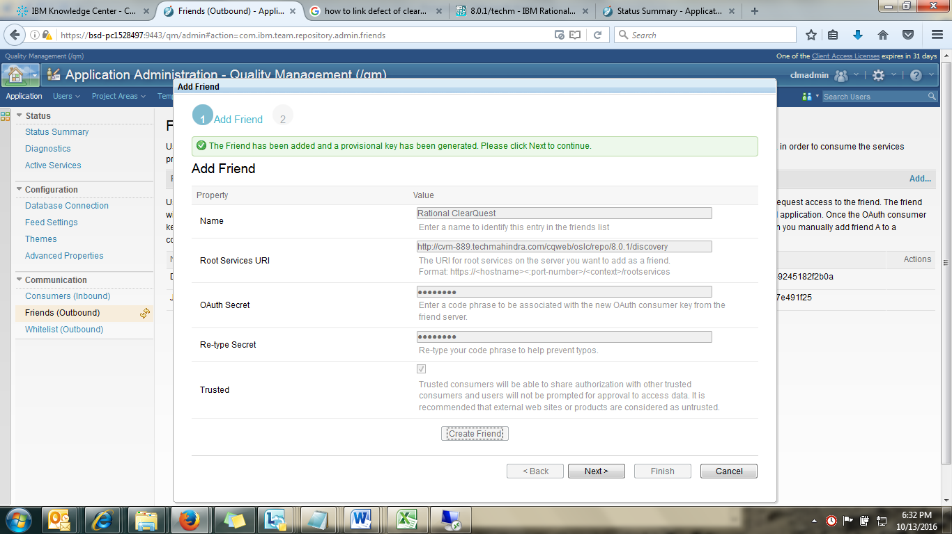

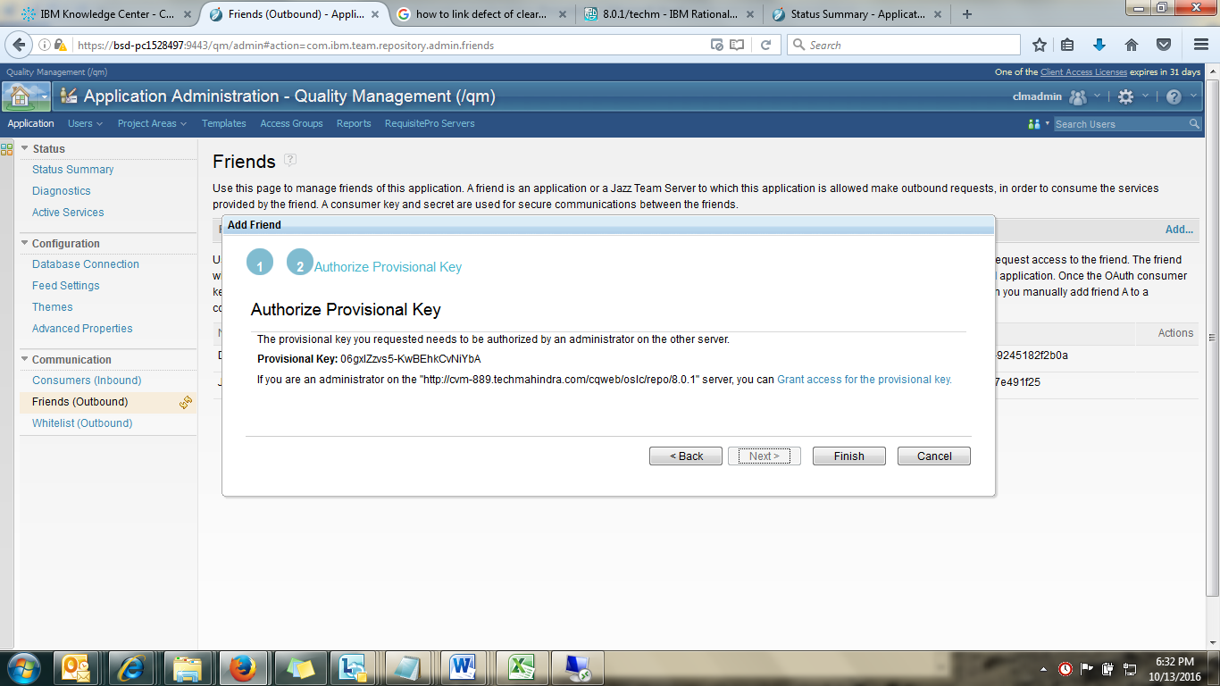

**Authorize Provisional Key**

The provisional key you requested needs to be authorized by an administrator on the other server.

**Provisional Key:** 06gxlZzvs5-KwBEhkCvNiYbA

If you are an administrator on the "http://cvm-889.techmahindra.com/cqweb/oslc/repo/8.0.1" server, you can Grant access for the provisional key.

